Recap
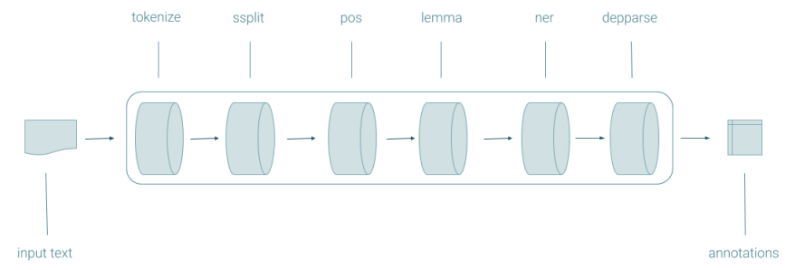
Tokenize: divide text into its symbols
Ssplit: divide a document in different sentences
POS (part-of-speech): each word of a test with its POS
Lemma: recover lemma form
NER (Neutral Entity Recognition): to which we refer in the text (which are the entities). Individuate which part of the text is referring to a person, organisation or entity. To recognise which entities are
Depparse: build a tree syntactic structure out of a text

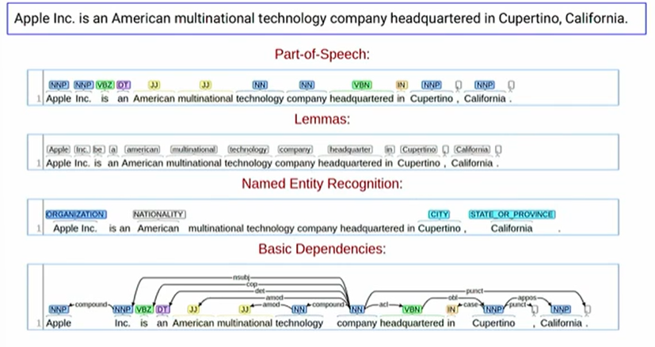

Some challenges of NLP

1- Productivity
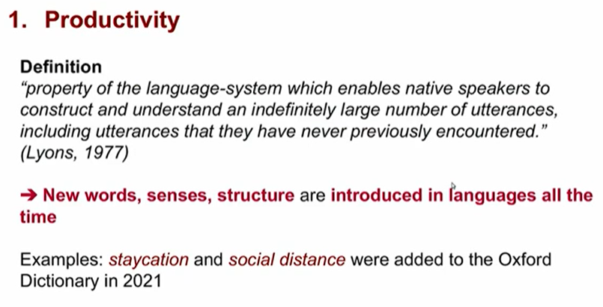

A language is not stationary: we can invent new words over time. A language will evolve with time

New words, senses, structure are introduced in languages all the time. Social distance was added to the Oxford Dictionary in 2021.

2-ambiguous
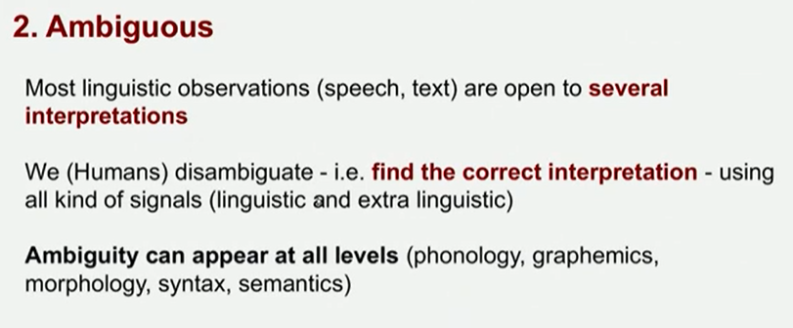
Language is ambiguous, it is open to interpretation.
The word Apple might refer to the fruit or to a company. Given a context we can disambiguate, but in NLP it is more difficult.

Most linguistic observations (speech, text) are open to several interpretations. Ambiguity can appear to all levels (phonology, graphemics, morphology, syntax, semantics)

We humans disambiguate (aka find the correct interpretation) using all kinds of signals. But it is more trivial to do automatically.

Syntactic ambiguity
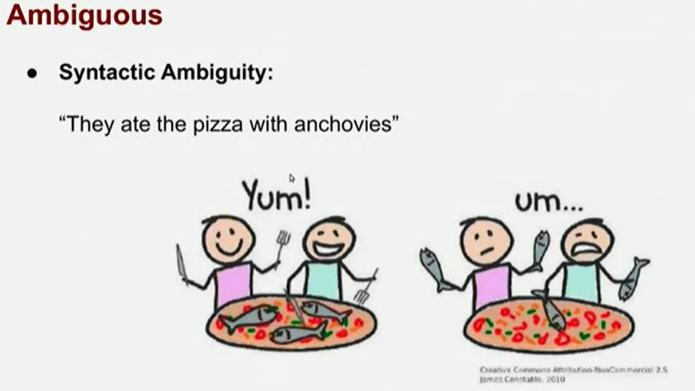
It is ambiguous, even if one seems to have more sense as a machine there are no clues.
they ate the pizza with anchovies

Semantic ambiguity
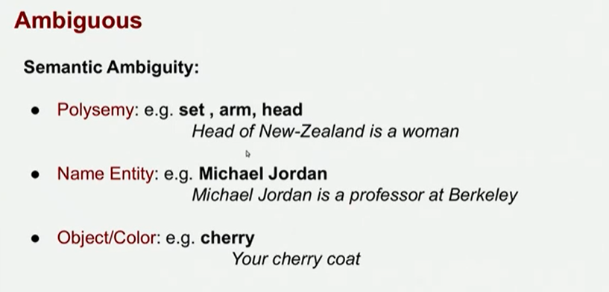
- Polysemy: set, arm, head: (the head is not only a part of the body but can also be the head of a country).
- Name entity: Michael Jordan (professor at Berkeley) but more commonly the basketball player.

- Object/colour: cherry (your cherry coat, refers to the colour)

Pragmatic ambiguity
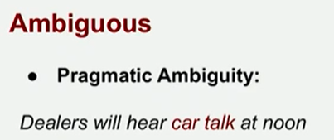
Dealers will hear car talk at noon. It is not that the cars will talk to each other.

For humans it is not hard to disambiguate, while for machines it is hard.

Disambiguating can requires discourse knowledge
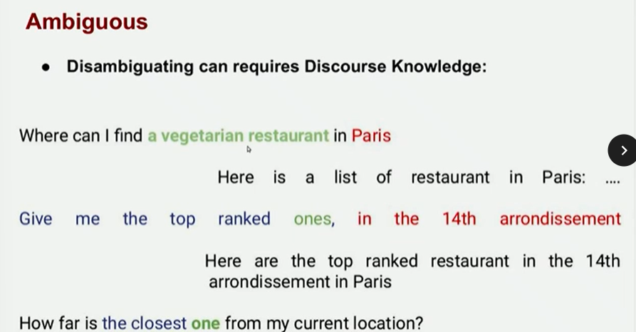
If we are having a conversation with Alexa or Google Assistant it needs to be able to understand that ones refers to vegetarian restaurants.

In the last one the term closest one refers to the above sentences. The systems must address all these types of ambiguities.

3-variability
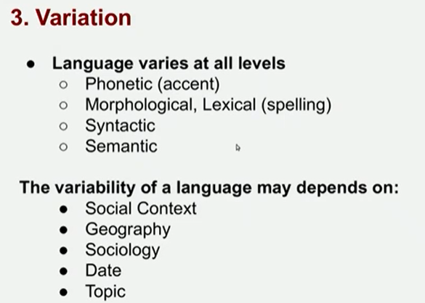
Language varies at all levels:
- Phonetic (accent) variation:
  - differences, do you pronounce r in arm. There is a lot of variation even with people that use English as their mother tongue.
  - 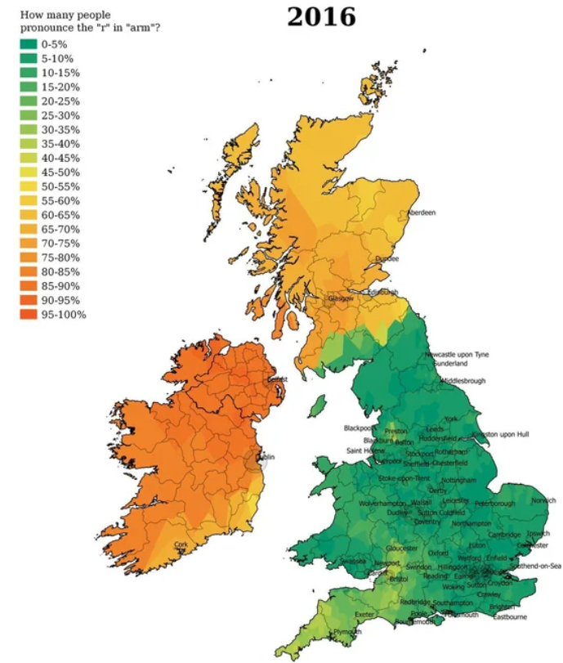
- morphological, lexical (spelling)
- Semantic

The variability of a language depends on a lot of factors
- Social context
- Geography
- Sociology
- Date
- Topic
- …

4-diversity
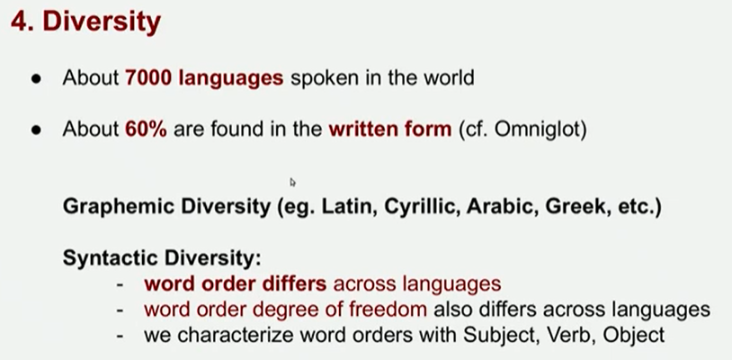
There are around 7000 languages spoken in the word, 60% have some type of written form

There is graphemic diversity (latin, cyrillic, arabic, greek…)

There is also syntactic diversity (word order = s-v-o vs s-o-v)
- Word order differs across languages
- Word order degree of freedom also differs across languages
- We characterise word orders with Subject, Verb, Object
- A single language can have different degrees of freedom (in ENG sometimes an adjective can be before the noun).

We need to think about all those problems that we need to think about when we develop an NLP system

5-sparse
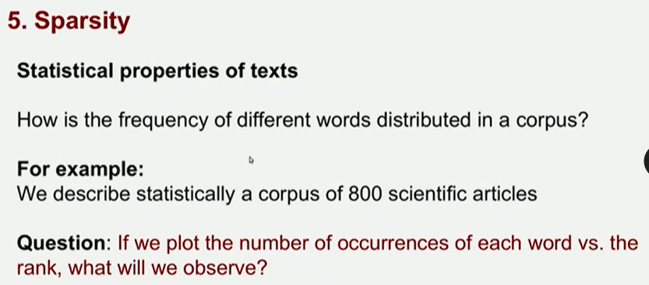
Statistical properties of text: how is the frequency of different words distributed in corpus?
Give a statistical description: n = occurrences of each word

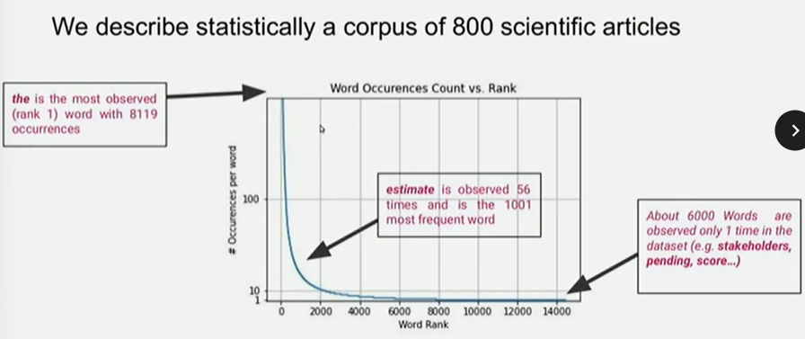
If we plot the number of occurrences of each word vs the rank, what will be observed? articles and connectives are the most common. We have very frequent terms and very rare terms.

the is the most observed word with 8119 occurcenes

We have a lot of other words that are observed only one time, very specific words.

Zipf law
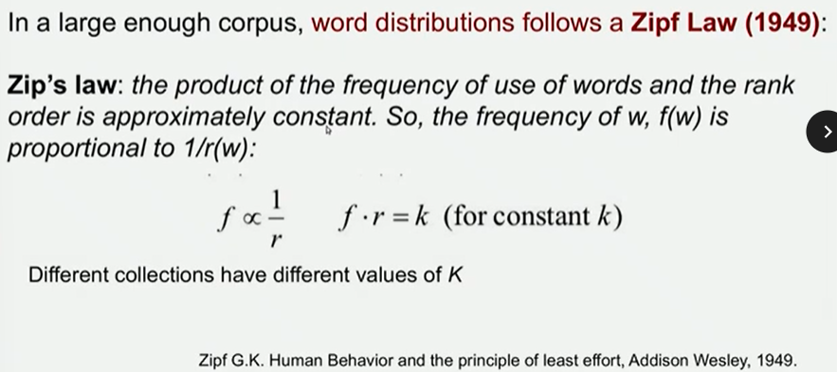

The product of the frequent use of words and the rank order is approximately constant.
The frequency of the word w, is proportional to 1/r(w) (the inverse of the rank)

f ∝ 1/r ⟹ f r = k (constant)

Basically we will get the same distribution of the words.
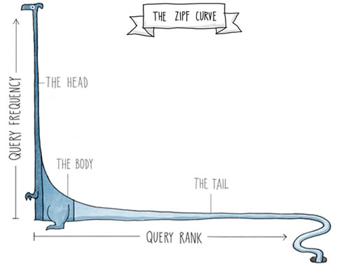
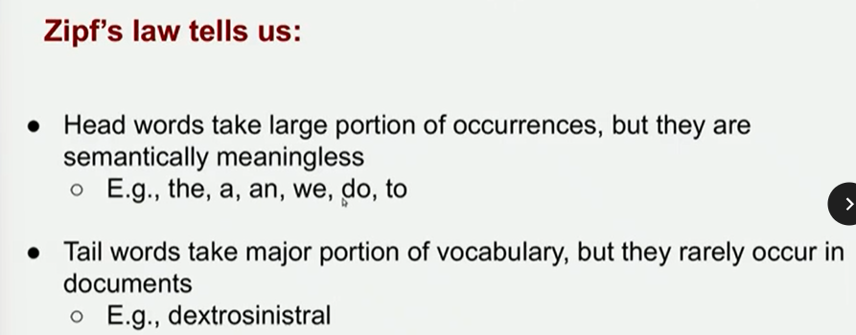

Head words take large portion of occurrences, but they are semantically meaningless
the, a, an, we, do, to

Tail words take major portion of vocabulary, but they rarely occur on documents
dextrosinistral

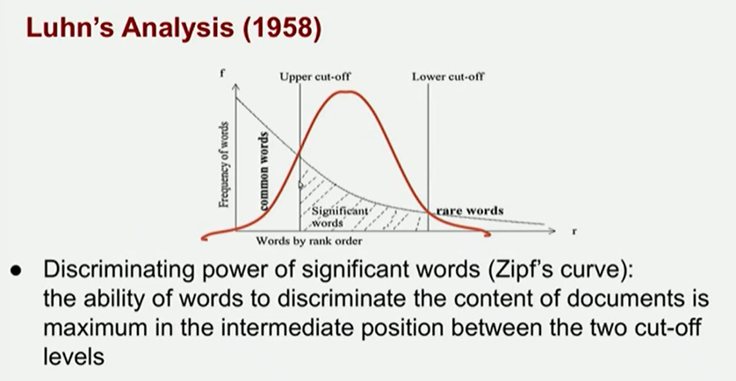
Luhn’s analysis
Discrimination power of significant words (Zipf’s curve): the ability of words to discriminate the content of documents is maximum in the intermediate portion between the two cut off levels
- Common words (head words)
- Significant words: most important one, makes us able to discriminate the content of a document (body words). Do not appear very often, but are also not very rare.
- Rare words (tail words)

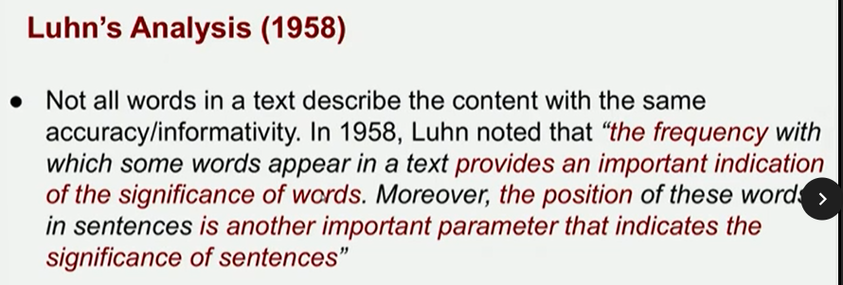

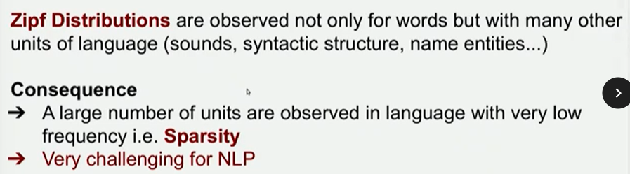

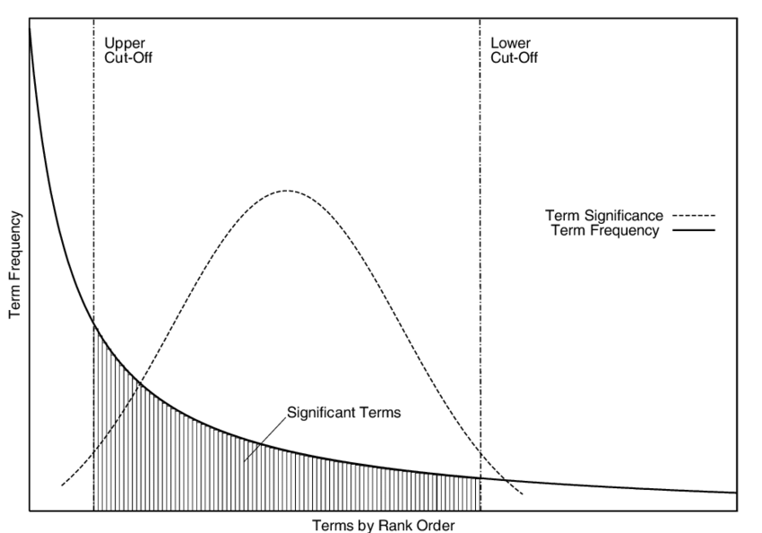

The position of the words is also an important parameter.

Zipf distribution are observed not only for words but with many other units of language (sounds, syntactic structure, name entities)

Consequence: a large number of units are observed in language with very low frequency: sparsity

Vector semantics
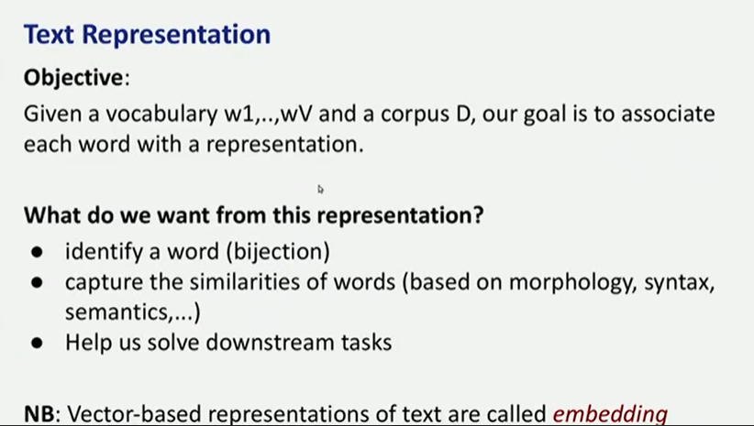

How we want to represent the words in a way that a computer can understand. Our goal is to associated each word with a representation

The representation should have some property
- Identity a word (bijection between the word and the representation): the representation must identity a single word, and the single word refers to a single representation
- The representation should capture the similarities of words (based on morphology, syntax, semantics)
  - Ex: apple and tree are somehow similar, they both represents nature
- Help us solve downstream tasks: if we want to build a conversation system this representation should be useful

Embedding: vector-based representation of text

vocabulary w₁,... . w_{v}
corpus D

ONE HOT ENCODING
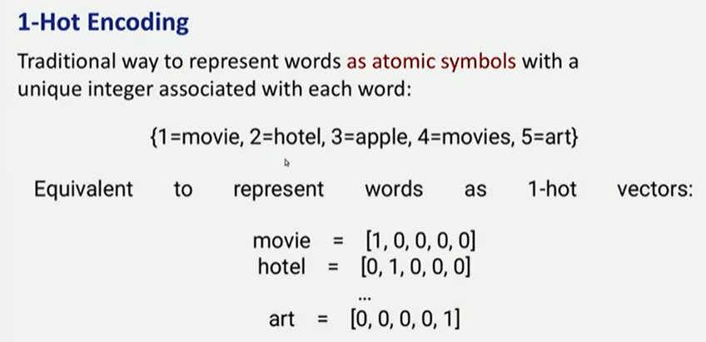
This it is one possibility to represent text in a way that a computer can process

Traditional way to represent words as atomic symbols: for each word we associate a vector (list of numbers). We have a unique integer associated with each word.

Ex: 1 = movie, 2 = hotel, 3 = apple, 4 = movies, 5 = art

movie = [1,0,0,0,0]
art = [0,0,0,0,1]

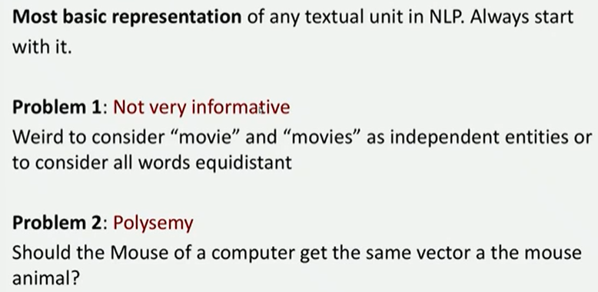

There are some problems with the one-hot encoding strategy:
- Not very informative: we consider movie and movies as independent entities. All words are equidistant and there no correlation encoded between different words
- Should the mouse of a computer get the same vector of the animal?

Binary term-document weighting
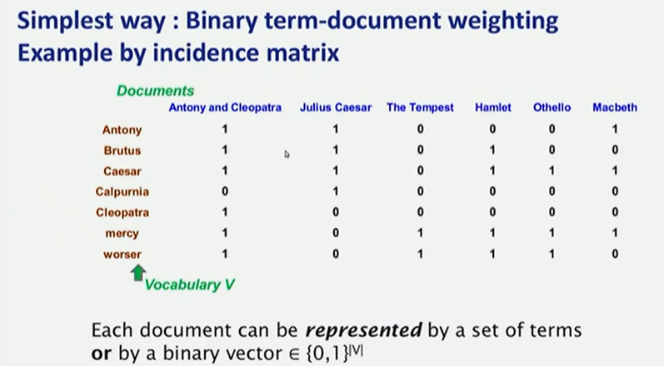
Each document can be represented by a set of terms OR by a binary vector € {0,1}^{|V|}

On columns: documents
On rows: all the words in that document

1: if the word appeared in the document
0: if the word was absent in the document

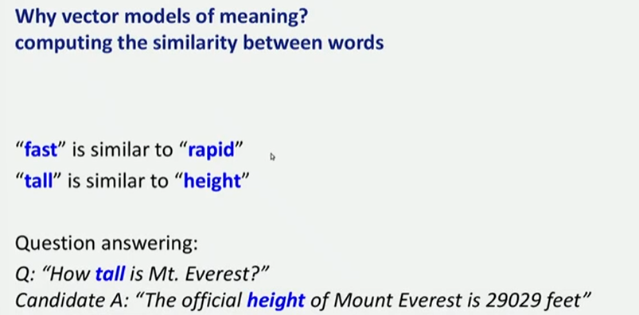
Why do we want to use a vector model of meaning?
Fast is similar to rapid.
tall is similar to height.

How tall is mt. everest? ⟹ The official height of mount everest is 29029 feet

We want to build something that is more informative, we want something that if we have fast and rapid it tells us that the two words are similar. We want to include some correlation between the representations.

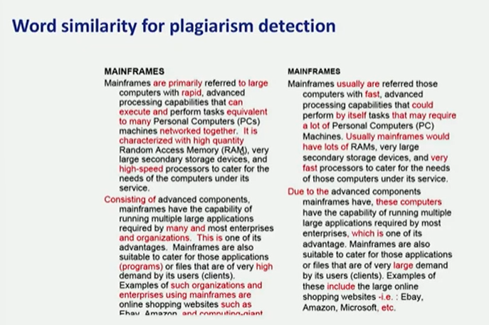
It can be used for words similar for plagiarism detection. If we have two documents we can look for plagiarism.

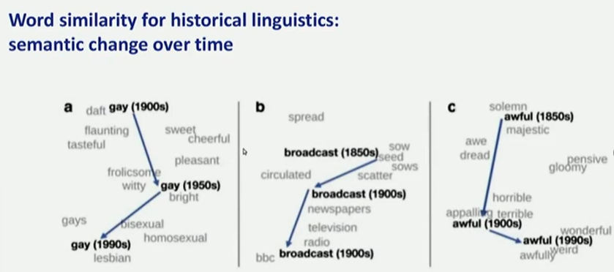
We can measure the semantic change of a word over time
change meaning of words (gay)

Hand-crafter feature representation
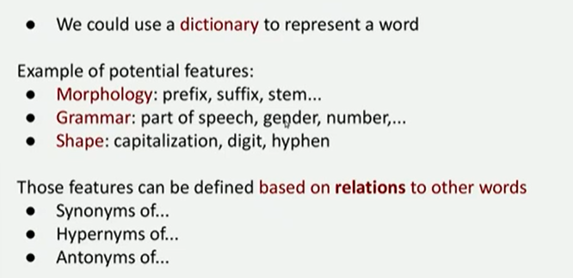
We could use a dictionary to represent a word. We can also insert the synonyms, hypernyms and antonyms

Example of potential features
- morphology: prefix, suffix, stem
- grammar: part of speech, gender, number
- shape: capitalization, digit, hyphen

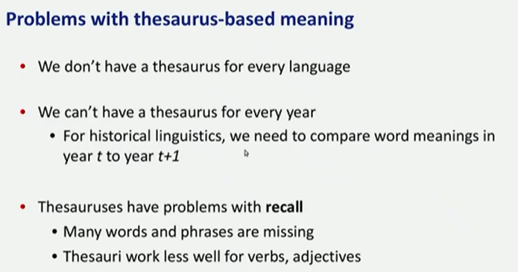
There are some problems of using a dictionary to represent a word
- A dictionary does not contains all the inflection of a word (there is no space for canticchiavamo in the dictionary). We only have lemmas
- Also we should update the dictionary every year

Those features can be defined based on relations to other words

Problem with thesaurus-based meaning

We don't have a thesaurus for every language
We can not have a thesaurus for every year. We need to compare word meanings in the year to year t+1

Distribution model of meaning
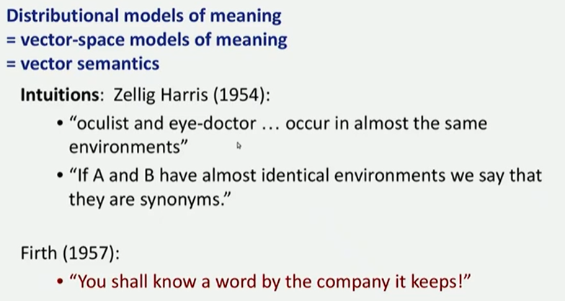
= vector-space modelis of meaning = vector semantics

Intuition of distributional word similarity
Zellig Harris: oculist and eye-doctor occur in almost the same environments

⟹ if two words A and B have almost identical environments we say that they are synonyms

Firth: you shall know a word by the company it keeps

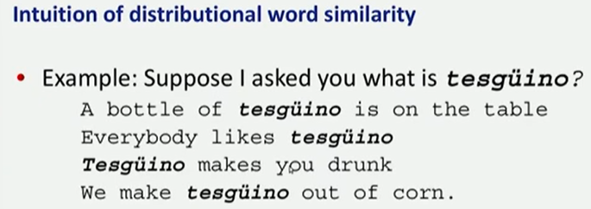
What does tesguino mean?
Tesguino: from contect words human can guess the meaning: alcoholic beverage like beer

Intuition: two words are similar if they have similar word contexts (this is the basis for most algorithm). By knowing the context we context we can infer what is similar to

four kinds of vector model
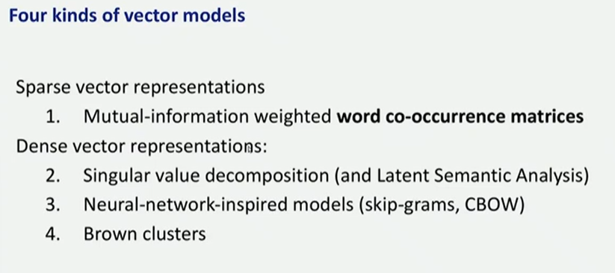
Shared intuition: model the meaning of a word by embedding it in a vector space. The meaning of a word is vector of number called embeddings

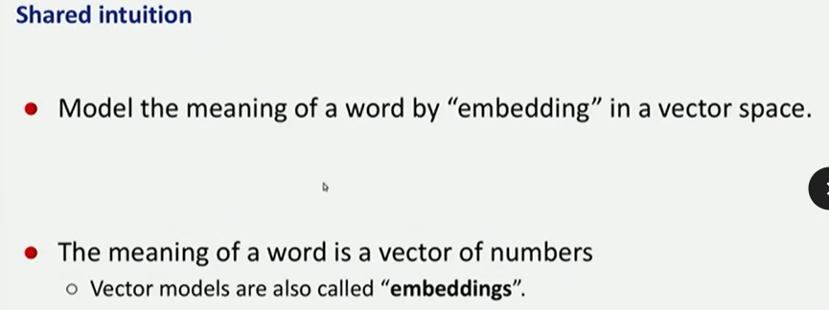

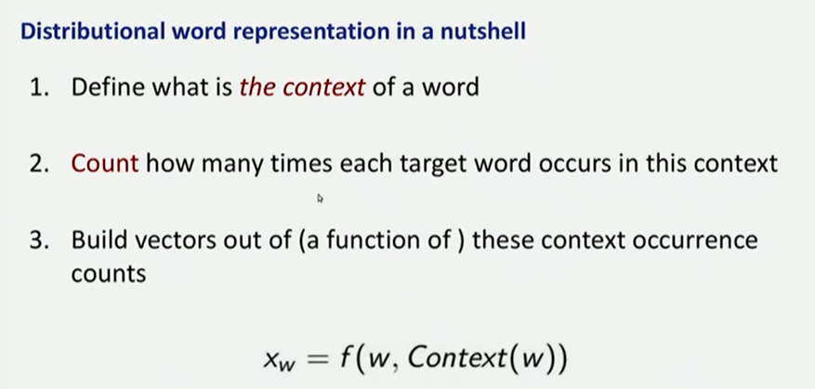
Count how many time a word happens,
function that takes in account the word and the context of a word.

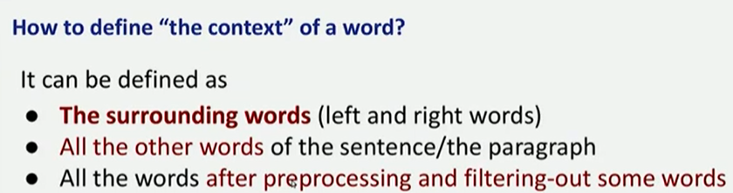
THE CONTEXT:
- Surrounding words: look 5 words on left and 5 on right
- Look all the other words of the sentence/paragraph
- All the words are pre processing and filtering out some words

We need to define first what is the context then we can think on how to build our function

Vector Semantics: words and co-occurrence vectors
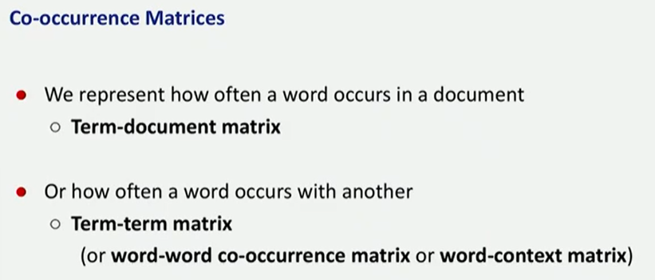
Term-document matrix: counts the number of times a word occurs in a document
Term-term (or word-word) matrix: count the number of times a word co-occours with others words

Term-document matrix
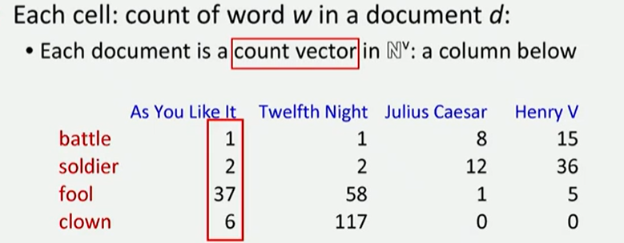
We need to build the co-occurrence matrix that counts the number of times a word occurs in a document.
Each document is a count vector N^{v}, column below. Each cell count of word w in a document d.

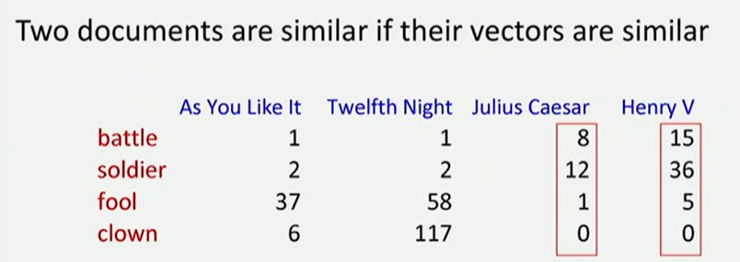
Each column is a vector.
Two documents are similar if the vectors are similar.

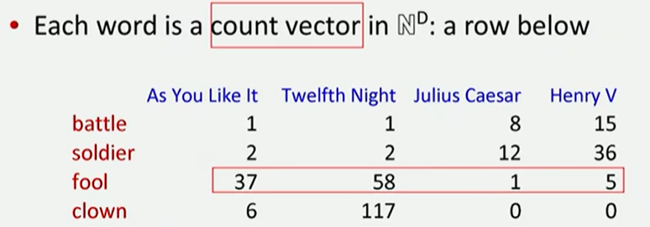
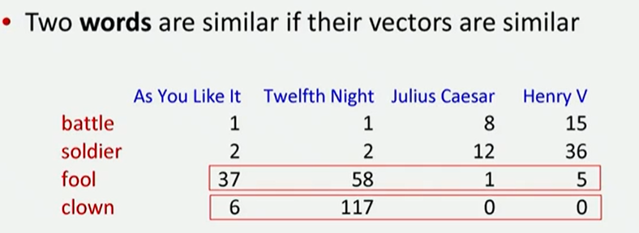
If we look at the row, it takes the representation for the word
Two words are similar is the two vector (horizontal) are similar

Term-term matrix (word-word matrix)
Slightly different from the term-document matrix.
Difference: the column is not anymore the size of documents but the size of the words. The vector is the cardinality of the vocabulary

Use smaller contexts than a document (either a paragraph or a window of some words). Defined by a vector over counts of a context words

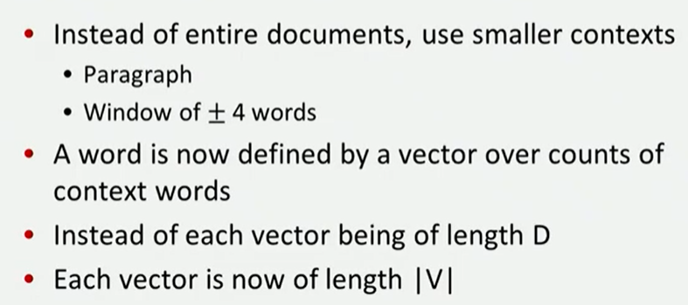

We first need to define context: it can define with a window of ±4 words
A word is now defined by a vector over counts of context words

Word-word matrix
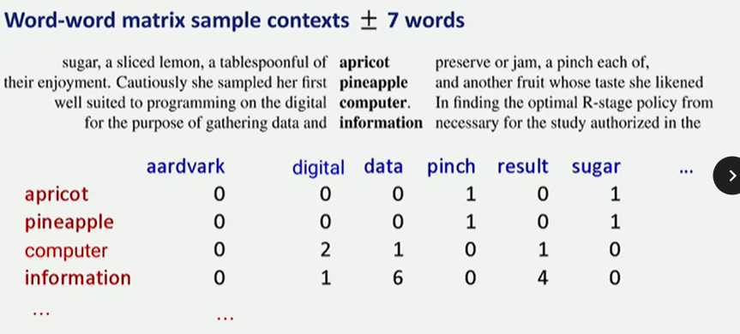
We choose a context of ±7 words.
Rows: target words
Columns: context words

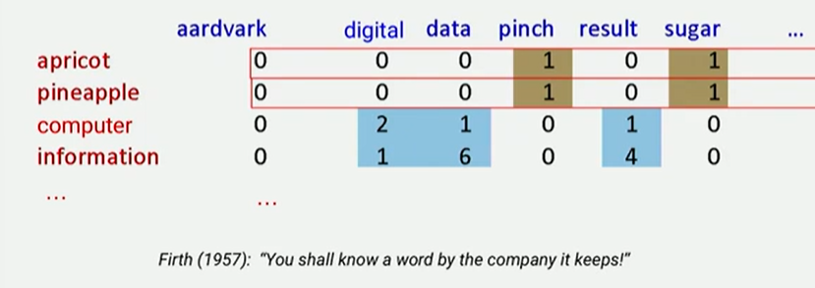
If the horizontal vectors are similar maybe the two words are close to each other

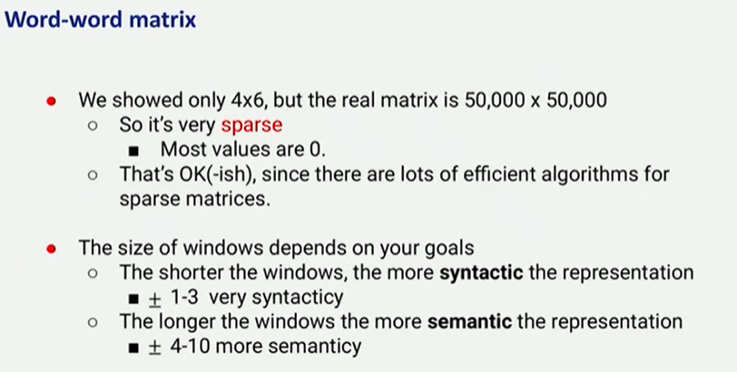
the real matrix is 50,000 x 50,000. It is very sparse (most values are 0)

There are lots of efficient algorithms for sparse matrices

The size of windows depends on your goal.
- Shorter windows (±1-3): more syntactic
- Longer windows (±4-10): more semantic

Vector semantics: positive pointwise mutual information (PPMI)
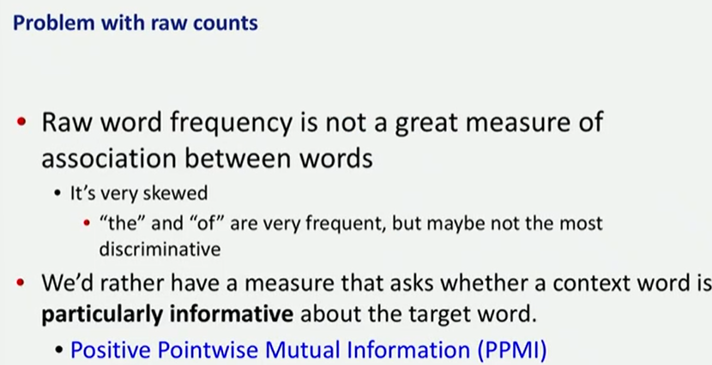
Raw word frequency is not a great measure of association between words.

Compute the probability of 2 words appearing together, divided by the single probability of the words appearing alone.

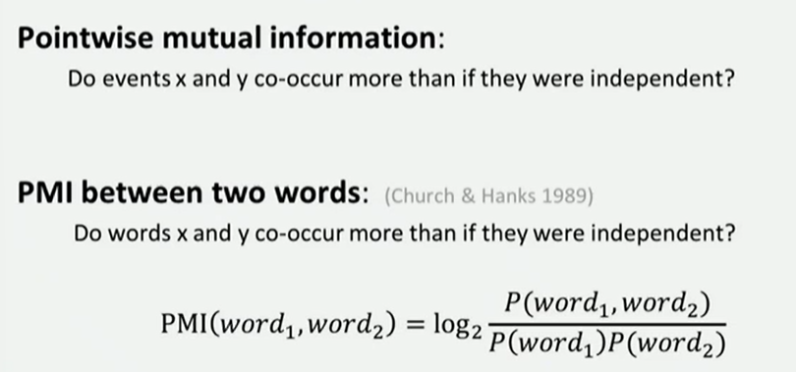

Do events x and y co-occur more than if they were independent
PMI between two words: do words x and y co-occurred more than if they were independent?

Need to compute of two words appearing together, divided by the probability of the two words appearing separately. Everything in log₂

Positive pointwise mutual information
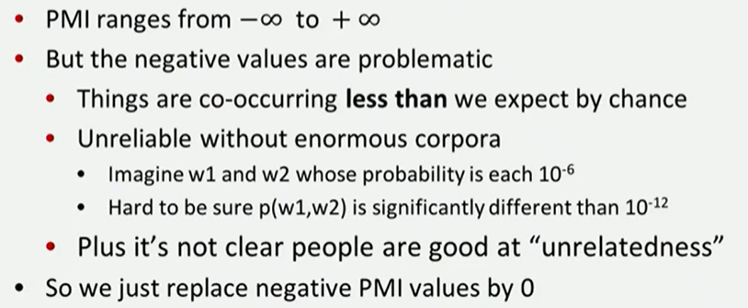
PMI ranges from -inf +inf
But the negative values are problematic, not really meaningful. No need to go in the negative part. It is hard to give a meaning, want to avoid this degree of unrelatdness

We replace negative PMI values by 0. If the result of the formula is negative we put a 0

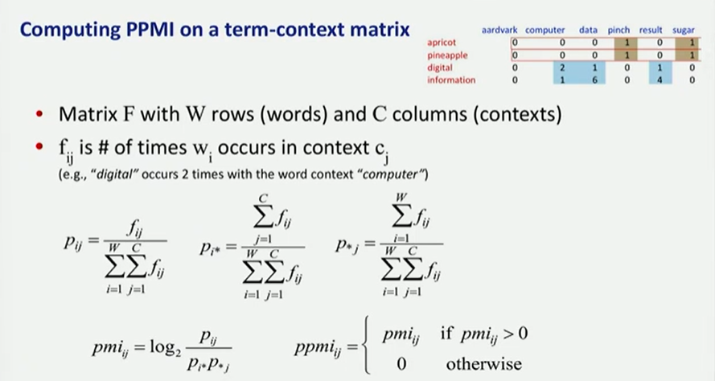
matrix F with W rows (words) and C columns (contexts)
f_{ij} is number of times w_{i} occurs in context c_{j}

We need three probability:
- P_{ij}: probability of two words being together, that is the number of times two words appear together divided by the sum (one that goes for the column, one for the row)
- P_{i*}: probability of the word appearing alone: summing across the columns all the counting
- P_{*j}: probability of the context: sum of the rows

Then we replace negative with 0

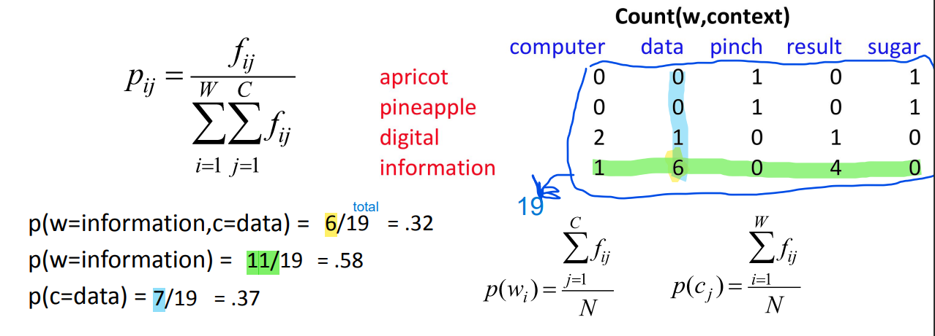

We want to compute the correlation between information and data.

Then we can do the same work for all the words:
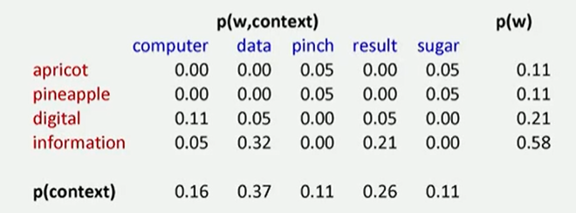

Then we can compute the PMI
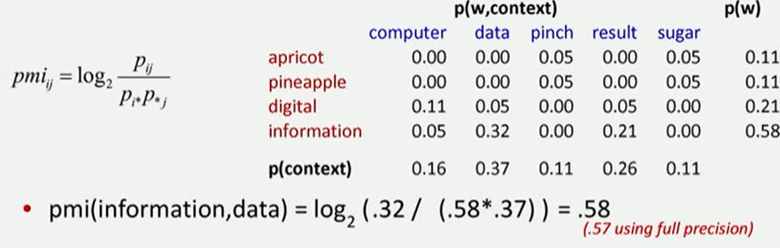

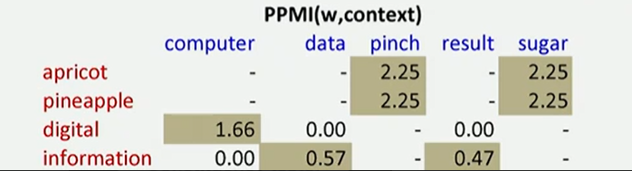

Weighting PMI

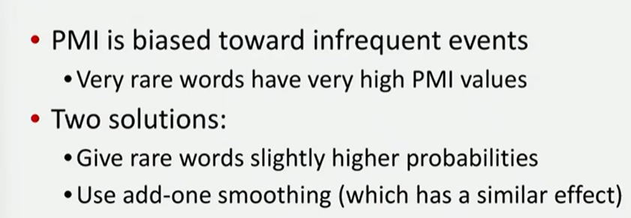
PMI is biassed toward infrequent events ⟹ very rare words have very high PMI values

Two solutions (with similar effect):
- Gives rare content words slightly higher probability
- Use add-one smoothing

Gives rare content words slightly higher probability

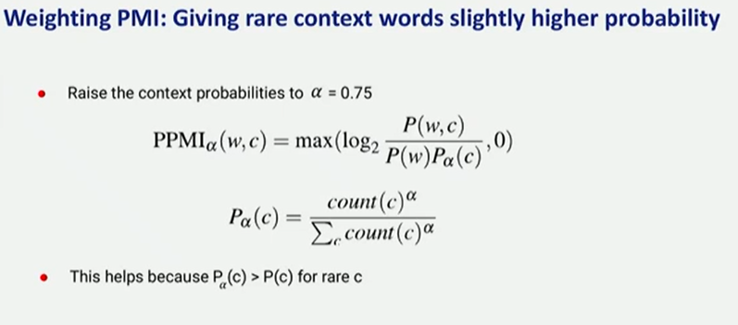
Take the same formula as before, but we raise the context probability to a value and that value is usually 0.75

Laplace Smoothing
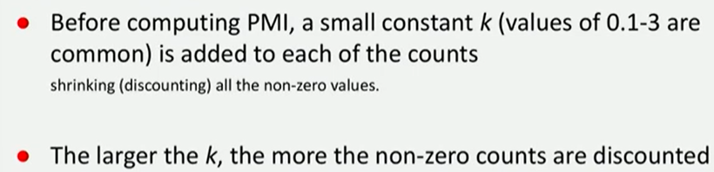
simply add a number between 0.1 and 3 for each context word. You have a similar result as before.

From this:
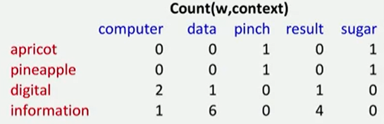

To this
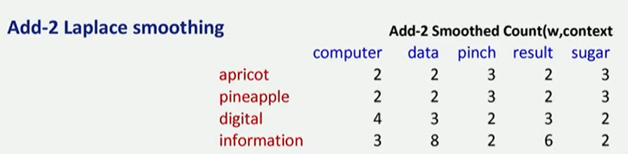

And we compute all the result again
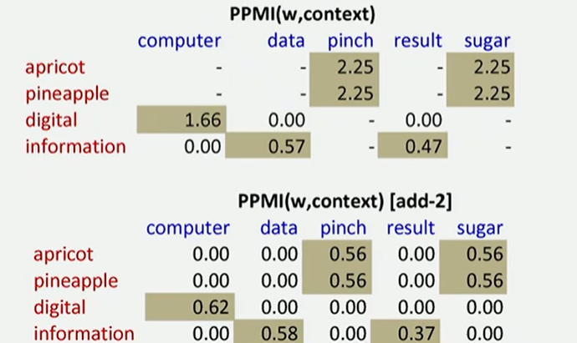

Using syntax to define a word’s context
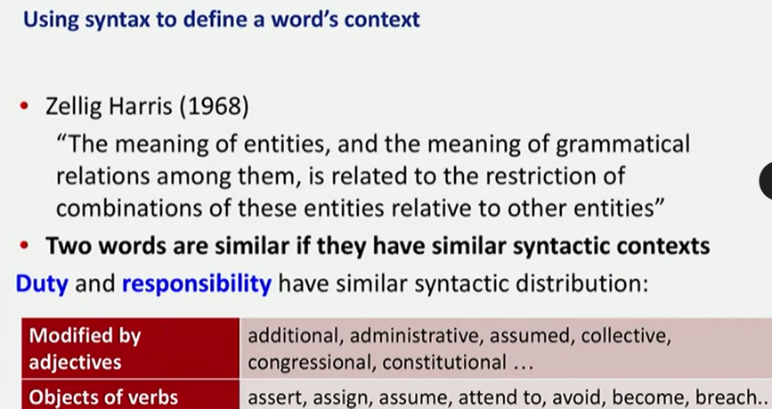
Two words are similar if they have similar syntactic context.

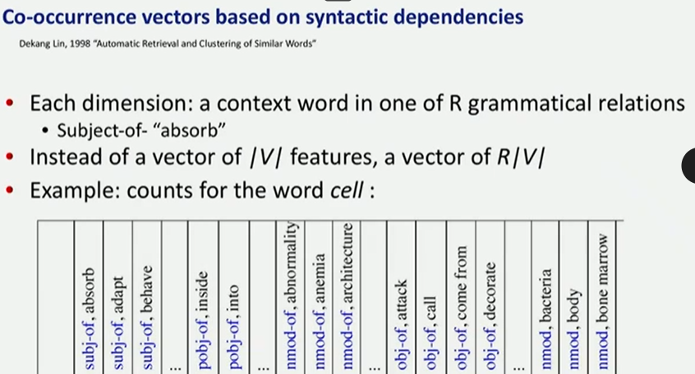
As context you can count instead of how many time a words appear together you can count how many times a word appear as a object of subject of a particular verb

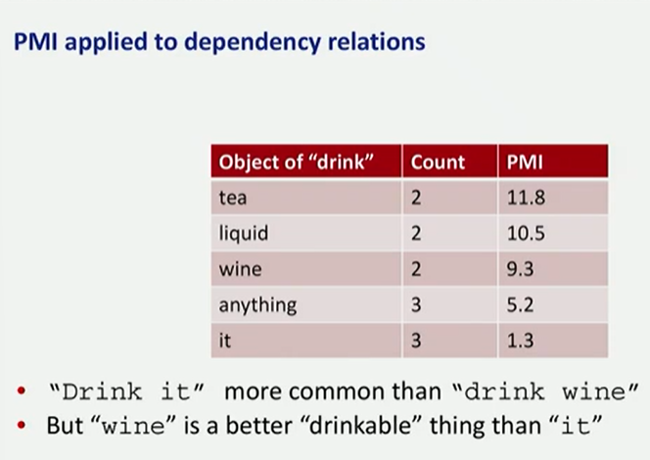
drink as a more common object the word wine (it more times than wine, but wine is more drinkable than it)
Pado Lapata alternative
- Instead of |V| x R|V| matrix
- we have a |V| x |V| matrix

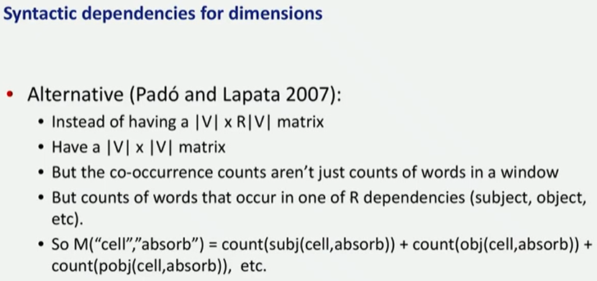
We will still have a matrix that is number of words * number of words

Alternative to PPMI for measuring association
PPMI is a good measure but there are others too

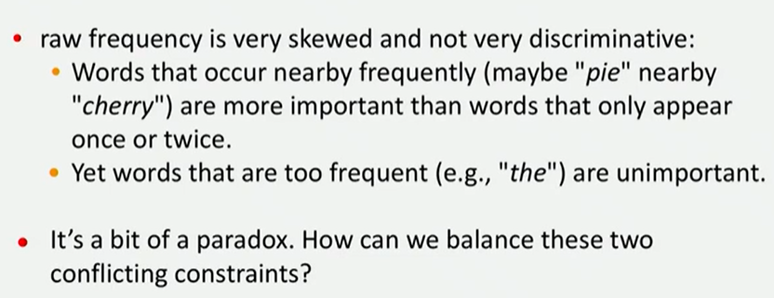
Problem: there are words that co-occour a lot but some of words that appear together are important, while some that appear together are not important.
Cherry and pie might appear together a lot of time and they might be important, while the and cherry also might happier together multiples time but they are not important as with pie

TF-IDF
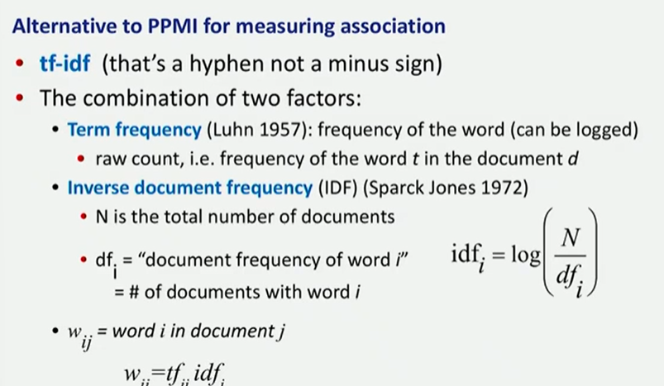
Combine two factors
- Term frequency: frequency of a word, how many times appears a word
- Inverse document frequency (idf):
  - N is the total number of documents we have
  - df_{i} number of documents what the word we are interest
  - w_{ij} word i in document j

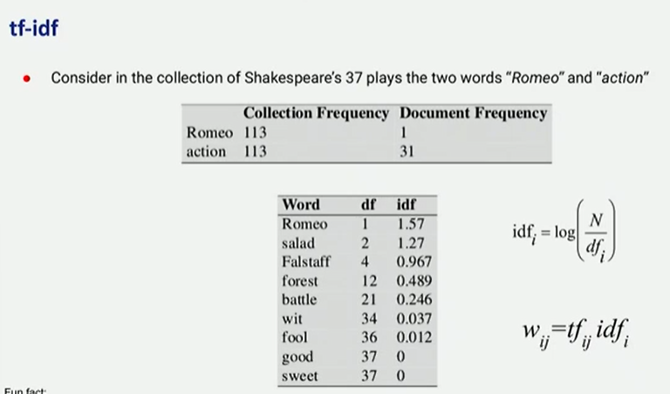

tf-idf not generally used for word-word similarity
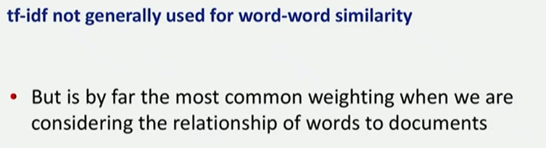
- But is by far the most common weighting when we are considering the relationship of words to documents

Vector semantics - measuring similarity the cosine
How we actually compute the similarity
measuring similarly: measure with the dot product

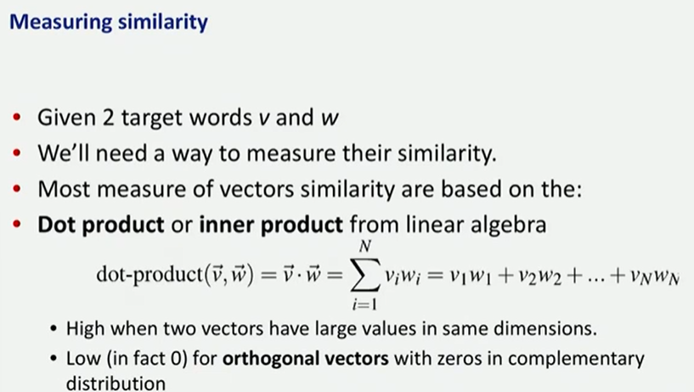

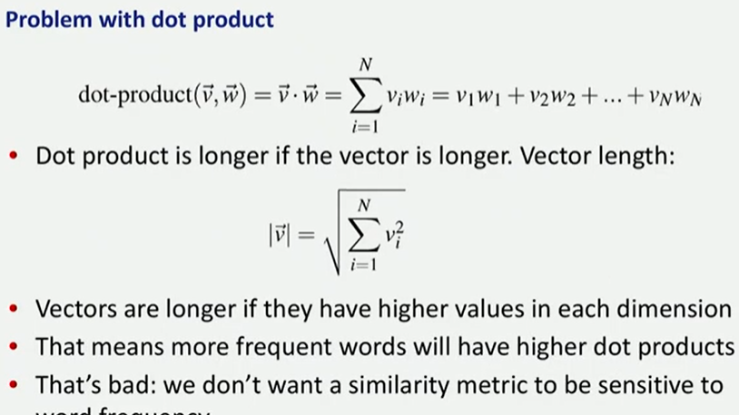
Problem: dot product will be longer if the vector is longer

The length of a vector is given by the formula. To address this problem we can normalise

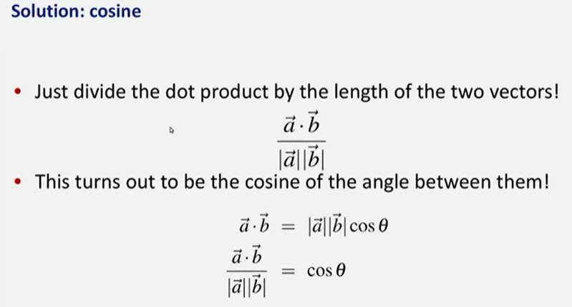
Use cosine similarity: compute the doctor product, and divide by the length of the two vector

Is the angle between two vectors

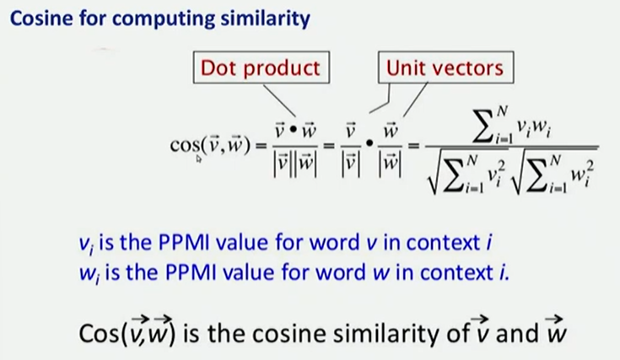

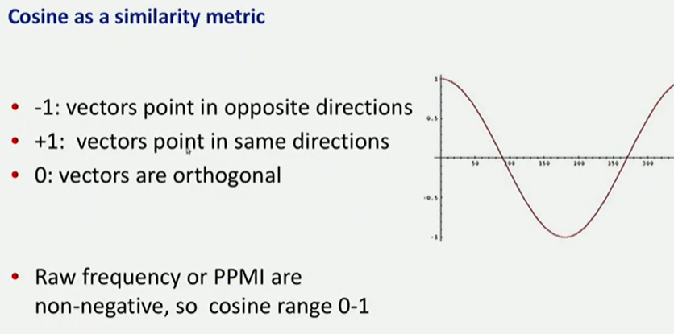
When it is 0 then the vectors are orthogonal

